RESULTS SUMMARY
Building youth leadership in emergencies in the Democratic Republic of Congo

Author: ActionAid Denmark (2025) Find project on OpenAid
PROJECT | Title: Building youth leadership in emergencies in the Democratic Republic of Congo (DRC)
PROJECT | Partner: Action Aid DRC, TCDC , Action Aid Tanzania
PROJECT | Country: Democratic republic of Congo(DRC)
PROJECT | Period: 2023-2025

CHANGE | The establishment and operationalisation of the Global Platform (GP) in Goma transformed how partners in Eastern DRC engage with youth in conflict contexts by creating a structured youth-led approach to humanitarian action. This change was driven by a combination of cross-country learning and facilitation led by ActionAid Denmark (AADK), in collaboration with TCDC and peer GPs, particularly exchange and mentorship with GP Tanzania and the adaptation of training models from AADK’s programme modality support

CONTEXT | Eastern DRC, particularly Goma and North Kivu, faces recurring crises from conflict, displacement, and climate shocks, yet young people remain excluded from leadership in humanitarian response. To address this, AA DRC, with support from AAADK and mentorship from the GP in Tanzania, established a youth-led GP in Goma. This shifted youth from passive recipients to active leaders, strengthening local ownership, building sustainable capacity, and increasing youth influence in humanitarian, peacebuilding, and climate justice efforts.

CONTRIBUTION | Structured capacity building led by AADK, TCDC, and AA Tanzania and exposure to global GP spaces connected AA DRC to the wider GP network. AA DRC staff participated in international ToT programmes in Kenya (2023) and Nepal (2024). Collaboration with GP Tanzania including co-facilitated trainings and a learning visit in 2025 translated global approaches into practical, locally owned models. AADK provided bilateral technical support and activity funds from the IGNITE fund.

IMAGES | 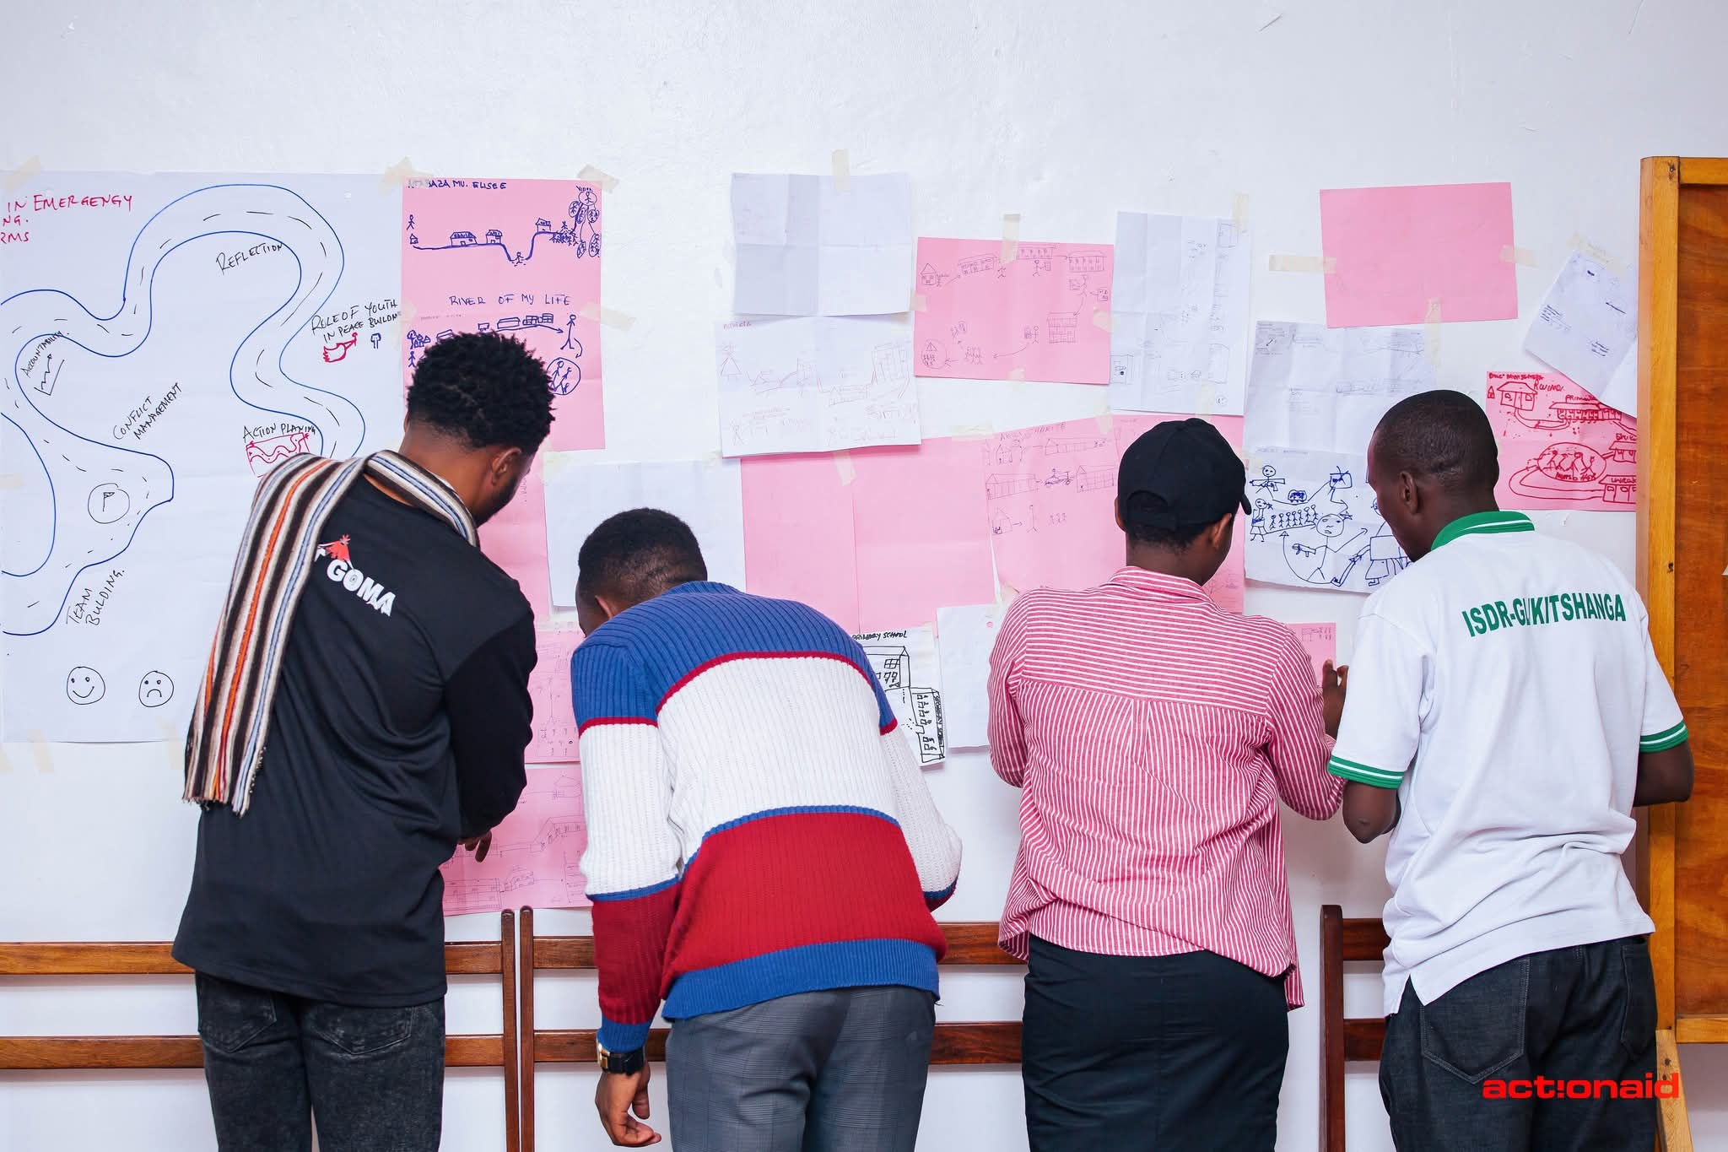  Young training participants from Goma engage in a practical group exercise, using visual tools and drawings. Credit : GP Secretariat | 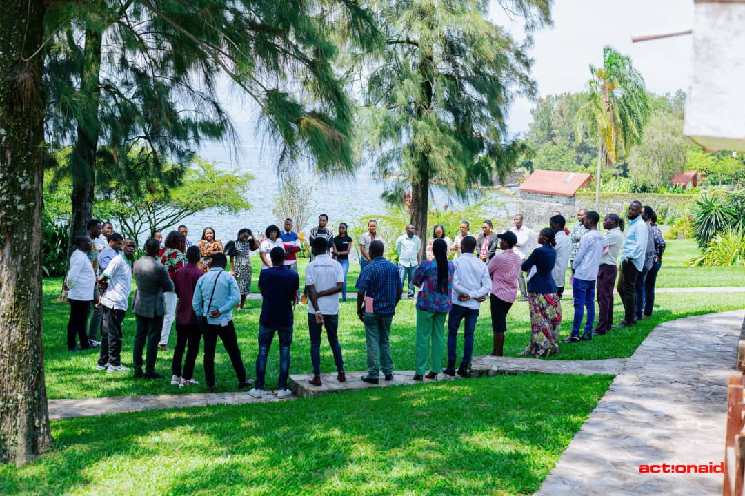  Participants take part in an outdoor reflection circle during the Youth Leadership in Humanitarian Emergencies training in Goma, fostering trust, shared learning. Credit : GP Secretariat
See next page for more details
ADDITIONAL INFORMATION

ACTIVITIES | In addition to implementing several step down trainings, which directly reached over 65 young people in Eastern DRC, staff and volunteers from the Global Platform DRC also engaged in global dialogues on youth leadership in emergencies. Notably, a young activist from DRC participated as a speaker at the 2025 Humanitarian Network and Partnership Week (HNPW), contributing to a multi-agency session hosted by ActionAid, UNICEF, UNFPA, Plan International, Save the Children, IFRC, and others, where experiences from Goma informed the launch of the Young Humanitarians Handbook. Beyond capacity gains, the GP actively contributed to humanitarian response efforts during the M23 conflict. Staff and volunteers applied their skills as first responders, supporting injured civilians, advancing peace advocacy, and facilitating scholarships for 40 vulnerable children.

LESSONS | The intervention highlights the importance of strengthening intentional linkages between Global Platform initiatives, grassroots activists, and broader movement-building efforts in DRC. Peer-to-peer learning across Global Platforms proved critical in accelerating institutional development, while combining training with sustained mentorship ensured longer-term sustainability and localisation of skills. The experience also demonstrated that young people in fragile contexts are ready to lead when given structured support and trust. Digital platforms enhanced cross-border collaboration and advocacy, and early integration of GP pedagogy reinforced the identity and effectiveness of emerging youth-led hubs.

EVIDENCE | The intervention demonstrates that structured cross-country learning and sustained mentorship led to the establishment of a functional, youth-led Global Platform in Goma and increased youth leadership in humanitarian response. The global exposure, South-South exchange with GP Tanzania, and catalytic support from ActionAid Denmark translated knowledge into locally owned systems and practices. Evidence for this includes participation of AA DRC staff in international Trainings of Trainers (Kenya 2023, Nepal 2024), documented step-down trainings reaching over 65 youth in Goma, mentorship and co-facilitation by GP Tanzania, and application of skills during the M23 crisis (e.g., first response actions and education support for 40 affected children). Further validation is seen in global engagement, including youth representation at HNPW 2025 and contributions to the Young Humanitarians Handbook. Testimonials from participating youth leaders during training in Goma in 2024: https://youtu.be/s80ZKJ560Pc?si=ftkrlK6Uxh5Xhex-

 | DOMAINS | Development strategy priorities: Climate & Green Solutions; Democratic values & human rights
 | DOMAINS | Changes in the lives of people facing poverty, marginalisation or vulnerability | Click or tap here to enter text.
 | DOMAINS | Changes in laws, policies and practices that affect people’s rights | Click or tap here to enter text.
 | DOMAINS | Changes in the capacity of organisations and communities to support rights | -X
 | DOMAINS | Changes in partnerships and collaborations that support people’s rights | -X
 | DOMAINS | Changes in participation of groups facing poverty, marginalisation or vulnerability | -X
 | DOMAINS | Changes in local leadership of development and humanitarian work | -X
GUIDANCE NOTE

This format consists of two overall sections: on page one, the results summary communicates results to an external audience using a brief summary of what has been achieved; while page two provides an opportunity to explain the background and evidence behind the claims made as part of the summary.

Page 1: Results summary
The results summary should outline of the overall change. This should be phrased in a clear and concise manner, focusing on the benefits for target groups or communities, and preferably start out by stating the overall key message as a one-line statement. It is thus important to prioritise what the key message should be and not attempt to describe every possible change that may have occurred.

Note that case studies should not describe all of the activities carried out during the implementation. Instead, it should focus on one or two key messages to be highlighted – which may also span several projects – and only outline activities to backup contributions to the highlighted change.

This can be illustrated as a “reverse funnel.” First, the “change” section introduces the overall results claim, which answers the “which.” Note that this is done before any details have been provided. Second, the “context” section outlines the problem being addressed by the project and the significance of the change. For example, by explaining “why” it benefits target groups or communities.

Finally, and lastly, the “contribution” section should provide examples to justify for “how” the intervention contributed to realising change. Note that this should focus on the plausible linkage between the change and intervention rather than describing details from activities. It is often useful to think of this as a reverse theory-of-change, i.e. “After we did X, then Y occurred, because of Z.”
Figure 1:
Reverse funnel for communication
Change – Results claim (Which?)
Context – Significance (Why?)
Contribution – Justification (How?)
First
Last

Page 2: Additional information
The second page should provide background and evidence for project’s contribution to change. It can also address technical issues that do not fit in the results summary. The section consists of the following sections:

- Activities: Whereas the “contribution” section on page one provides a brief summary of the project contributions to change, the “activities” section allows for more detail on the project design, organisation and underlying activities in support of the contributions made.

- Lessons: Describes lessons learned through the implementation. These should relate to the results claim or alternatively the project(s) as a whole. Please consider (1) novelty – i.e. whether the change represents something new – and (2) the potential to scale and/or build on lessons going ahead.

- Evidence: A narrative comparison between results claims and the underlying evidence. It should answer “X led to Y, because of Z,” although it does not need to be phrased this way. It is useful to include references to a few selected documents for further details. Please see guidelines for more.

- Domains and development strategy: Describes contributions to defined domains and the Danish development strategy. Please consider limiting the number of domains to a few selected ones.

