RESULTS SUMMARY
People Power: building an international ecosystem to support and learn with movements

Author: ActionAid Denmark (2025) Find project on OpenAid
PROJECT | Title: People Power: building an international ecosystem to support and learn with movements
PROJECT | Partner: Danish Youth Council, Danish Institute for Parties and Democracy, CIVICUS, Peace Direct, Berghof Foundation, Community of Practice on Protection, OHCHR and Humanity United, Powered By the People CAAF, OSF
PROJECT | Country: International
PROJECT | Period: 2025

CHANGE | ActionAid Denmark (AADK) has strengthened social movements’ influence by connecting frontline actors with donors, policymakers, and global platforms through sustained convenings and alliances. This has led to increased access to funding and partnerships, the establishment of a global Community of Practice on Protection, and growing uptake of movement-centred approaches by institutions and donors. Broader systemic shifts in civic space protection and long-term funding remain ongoing despite agenda-setting influence.

CONTEXT | Sustainable progress on climate justice, peace, and democratic resilience requires stronger engagement with social movements, especially amid shrinking civic space and declining trust in institutions. However, movements remain under-recognised, under-supported, and weakly connected to institutional actors, while stakeholders lack effective frameworks to engage them as equal partners. This gap was addressed by convening cross-sector collaboration and shaping global dialogue on the role of movements in driving structural change.

CONTRIBUTION | With AADKs social movement hub (MOVE) as the engine, AADK bridges grassroots movements and global decision-making spaces through trusted relationships, structured convening methodologies, and strategic partnerships. AADK ensures that frontline actors shape agendas rather than being included at the margins through grounded partner-led processes. MOVE translates knowledge into policy-relevant formats e.g., publications, foresight processes, tools, and brokers relationships with donors and institutions.

IMAGES | 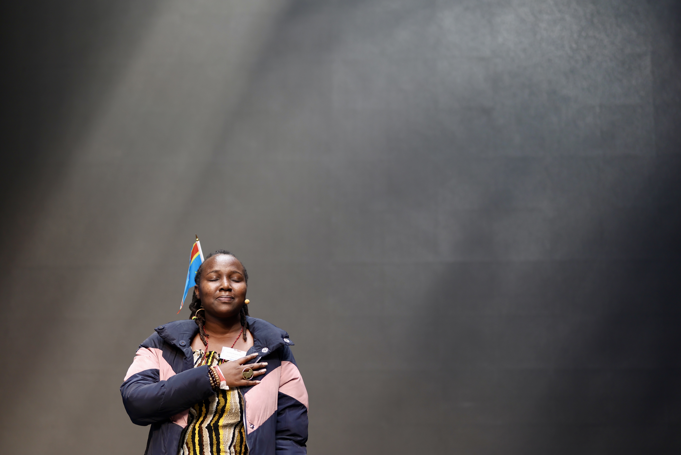  Eliane Feza, a displaced poetry slam activist, or “slameuse” from DR Congo, performing at Copenhagen People Power Conference, April 2025. Credit: William Vest-Lillesøe | 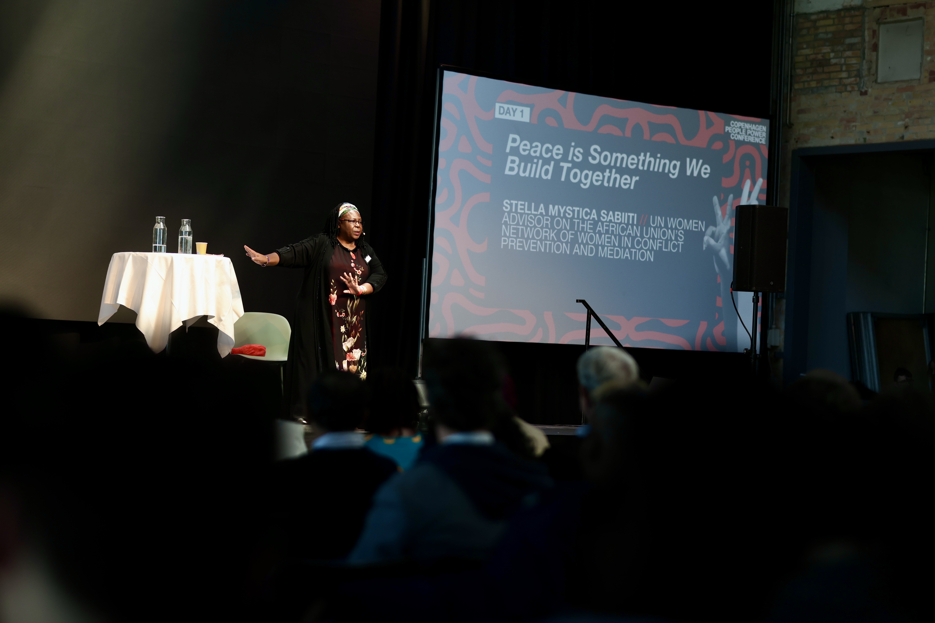  Stella Mystica Sabiiti, UN Women Advisor to the African Union (AU)’s Network of Women in Conflict Prevention and Mediation, speaks at Copenhagen People Power Conference, April 2025. Credit: William Vest-Lillesøe
See next page for more details
ADDITIONAL INFORMATION

ACTIVITIES | The project used a partner-led convening model centred on frontline priorities, applying a 40-20-40 approach (pre-engagement, conference, follow-up). Pre-engagement included consultations with activists from conflict contexts, webinars, publications, and targeted dialogues with donors and governments. The conference created spaces for direct engagement between movements and decision-makers, including closed donor and government sessions. Follow-up initiatives such as the Community of Practice on Protection and practical toolkits ensured sustained collaboration, learning, and influence. Strategic partnerships with research institutions and media further amplified impact, translating movement knowledge into widely used tools and increasing public and policy engagement.

LESSONS | Co-created, movement-centred convenings strengthen trust, legitimacy, and cross-sector collaboration especially when designed as sustained processes that link dialogue to concrete follow-up and action. Early and meaningful partner involvement is critical to ensuring relevance, ownership, and impact.The experience shows that effective engagement with social movements requires both safe spaces for dialogue and structured pathways into policy and funding systems. Building long-term, trust-based relationships with donors and partners around shared priorities enhances both influence and sustainability.

EVIDENCE | Evidence is reflected in the structured 40-20-40 convening approach, including pre-engagement with activists from conflict contexts, the conference (600+ participants), and sustained follow-up initiatives such as the Community of Practice on Protection and practical toolkits. Institutional uptake further confirms impact, including contributions to UN human rights dialogues, training of 80 OHCHR staff, and recognition by UNPBSO. The REACT initiative provides additional evidence, with 24 activist-led publications (20,000+ views) and engagement of over 400 participants, demonstrating sustained knowledge sharing and influence. https://www.nonviolent-conflict.org/resource/towards-a-peoples-peace-a-task-for-activists-peacebuilders-and-allies/

 | DOMAINS | Development strategy priorities: Democratic values & human rights
 | DOMAINS | Changes in the lives of people facing poverty, marginalisation or vulnerability | -
 | DOMAINS | Changes in laws, policies and practices that affect people’s rights | -
 | DOMAINS | Changes in the capacity of organisations and communities to support rights | X
 | DOMAINS | Changes in partnerships and collaborations that support people’s rights | X
 | DOMAINS | Changes in participation of groups facing poverty, marginalisation or vulnerability | X
 | DOMAINS | Changes in local leadership of development and humanitarian work | -
GUIDANCE NOTE

This format consists of two overall sections: on page one, the results summary communicates results to an external audience using a brief summary of what has been achieved; while page two provides an opportunity to explain the background and evidence behind the claims made as part of the summary.

Page 1: Results summary
The results summary should outline of the overall change. This should be phrased in a clear and concise manner, focusing on the benefits for target groups or communities, and preferably start out by stating the overall key message as a one-line statement. It is thus important to prioritise what the key message should be and not attempt to describe every possible change that may have occurred.

Note that case studies should not describe all of the activities carried out during the implementation. Instead, it should focus on one or two key messages to be highlighted – which may also span several projects – and only outline activities to backup contributions to the highlighted change.

This can be illustrated as a “reverse funnel.” First, the “change” section introduces the overall results claim, which answers the “which.” Note that this is done before any details have been provided. Second, the “context” section outlines the problem being addressed by the project and the significance of the change. For example, by explaining “why” it benefits target groups or communities.

Finally, and lastly, the “contribution” section should provide examples to justify for “how” the intervention contributed to realising change. Note that this should focus on the plausible linkage between the change and intervention rather than describing details from activities. It is often useful to think of this as a reverse theory-of-change, i.e. “After we did X, then Y occurred, because of Z.”
Figure 1:
Reverse funnel for communication
Change – Results claim (Which?)
Context – Significance (Why?)
Contribution – Justification (How?)
First
Last

Page 2: Additional information
The second page should provide background and evidence for project’s contribution to change. It can also address technical issues that do not fit in the results summary. The section consists of the following sections:

- Activities: Whereas the “contribution” section on page one provides a brief summary of the project contributions to change, the “activities” section allows for more detail on the project design, organisation and underlying activities in support of the contributions made.

- Lessons: Describes lessons learned through the implementation. These should relate to the results claim or alternatively the project(s) as a whole. Please consider (1) novelty – i.e. whether the change represents something new – and (2) the potential to scale and/or build on lessons going ahead.

- Evidence: A narrative comparison between results claims and the underlying evidence. It should answer “X led to Y, because of Z,” although it does not need to be phrased this way. It is useful to include references to a few selected documents for further details. Please see guidelines for more.

- Domains and development strategy: Describes contributions to defined domains and the Danish development strategy. Please consider limiting the number of domains to a few selected ones.

