RESULTS SUMMARY
Government of Tanzania establishes the climate change financing department

Author: ActionAid Denmark (2025) Find project on OpenAid
PROJECT | Title: Government of Tanzania establishes the climate change financing department
PROJECT | Partner: ForumCC,DRST,TAYOTA, ActionAid Tanzania
PROJECT | Country: Tanzania
PROJECT | Period: February 2025

CHANGE | In response to sustained advocacy and accountability efforts led by climate justice actors, the Government of Tanzania has announced plans to establish a Climate Change Financing Department within the Ministry of Finance, strengthening institutional capacity to coordinate climate finance mobilization and planning.

CONTEXT | Historically, responses to climate-related shocks in Tanzania relied on ad hoc mobilization of resources from government and private sector actors after emergencies occur, leading to delays and inefficiencies. For example, in 2024, ActionAid Tanzania (AATZ) and partners mobilized additional resources to respond to flooding in several localities. AATZ engaged government stakeholders to advocate for more structured, proactive approaches and clear preparedness and response plans for climate-related emergencies.

CONTRIBUTION | ActionAid Tanzania, through the SPAII Programme and alongside other climate justice actors, contributed to this outcome by advocating for improved preparedness and more reliable, institutionalized mechanisms for financing and responding to climate change emergencies.

IMAGES |   Panel of speakers from FORUMCC, Mpwapwa District and Chamwino District. Credit at Climate Change Annual Policy Symposium : Action Aid Tanzania | 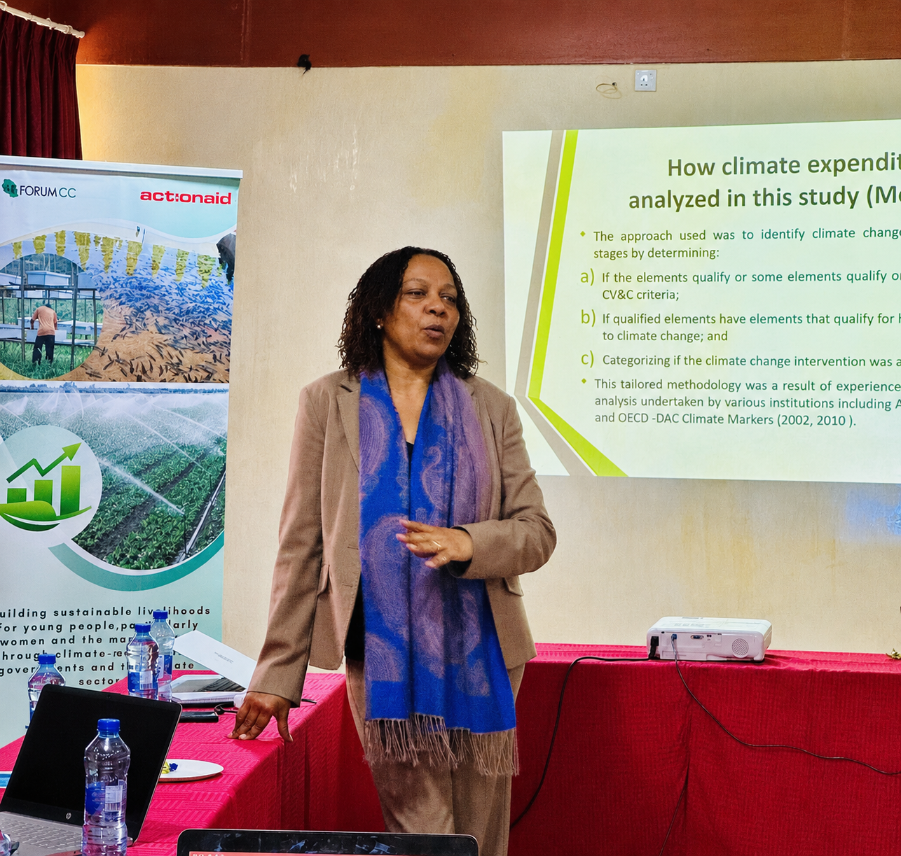  ForumCC Technical Advisor in discussion with Ministry of Agriculture officials on climate financing under Ministerial Department Advocacy initiatives. Credit: ActionAid Tanzania
See next page for more details
ADDITIONAL INFORMATION

ACTIVITIES | The programme organized and supported a range of targeted advocacy and engagement actions aimed at strengthening climate finance systems. These included convening the Annual Climate Change Policy Symposium, conducting studies on climate financing, and facilitating engagement meetings with key decision-makers, including Parliamentary Departmental Committees and relevant ministry departments. The programme also contributed to the National Dialogue on Financing for Development and supported advocacy efforts through various civil society consortiums. All these activities were strategically designed to influence government action towards improving the coordination, mobilization, and management of climate finance.

LESSONS | Strategic and sustained engagement by civil society organizations (CSOs) demonstrates strong potential to influence political will and drive government action on climate change priorities. The experience shows that coordinated advocacy, evidence generation, and multi-stakeholder dialogue can contribute to shifts toward more structured climate finance systems. However, continued and intensified efforts by CSOs are necessary to ensure that the proposed Climate Change Financing Department is fully operationalized, with adequate resources mobilized, allocated, and effectively utilized to achieve its intended impact.

EVIDENCE | Evidence of this change is reflected in the Government of Tanzania’s public announcement to establish a Climate Change Financing Department within the Ministry of Finance, as reported by national media. This development aligns with sustained, evidence-based advocacy efforts by civil society organizations, including ActionAid Tanzania, calling for strengthened and more accountable public climate financing mechanisms. Source: https://www.thecitizen.co.tz/tanzania/news/national/tanzania-to-establish-climate-change-finance-department-4933614

 | DOMAINS | Development strategy priorities: Climate & Green Solutions; Democratic values & human rights
 | DOMAINS | Changes in the lives of people facing poverty, marginalisation or vulnerability | X
 | DOMAINS | Changes in laws, policies and practices that affect people’s rights | X
 | DOMAINS | Changes in the capacity of organisations and communities to support rights | -
 | DOMAINS | Changes in partnerships and collaborations that support people’s rights | -
 | DOMAINS | Changes in participation of groups facing poverty, marginalisation or vulnerability | -
 | DOMAINS | Changes in local leadership of development and humanitarian work | -
GUIDANCE NOTE

This format consists of two overall sections: on page one, the results summary communicates results to an external audience using a brief summary of what has been achieved; while page two provides an opportunity to explain the background and evidence behind the claims made as part of the summary.

Page 1: Results summary
The results summary should outline of the overall change. This should be phrased in a clear and concise manner, focusing on the benefits for target groups or communities, and preferably start out by stating the overall key message as a one-line statement. It is thus important to prioritise what the key message should be and not attempt to describe every possible change that may have occurred.

Note that case studies should not describe all of the activities carried out during the implementation. Instead, it should focus on one or two key messages to be highlighted – which may also span several projects – and only outline activities to backup contributions to the highlighted change.

This can be illustrated as a “reverse funnel.” First, the “change” section introduces the overall results claim, which answers the “which.” Note that this is done before any details have been provided. Second, the “context” section outlines the problem being addressed by the project and the significance of the change. For example, by explaining “why” it benefits target groups or communities.

Finally, and lastly, the “contribution” section should provide examples to justify for “how” the intervention contributed to realising change. Note that this should focus on the plausible linkage between the change and intervention rather than describing details from activities. It is often useful to think of this as a reverse theory-of-change, i.e. “After we did X, then Y occurred, because of Z.”
Figure 1:
Reverse funnel for communication
Change – Results claim (Which?)
Context – Significance (Why?)
Contribution – Justification (How?)
First
Last

Page 2: Additional information
The second page should provide background and evidence for project’s contribution to change. It can also address technical issues that do not fit in the results summary. The section consists of the following sections:

- Activities: Whereas the “contribution” section on page one provides a brief summary of the project contributions to change, the “activities” section allows for more detail on the project design, organisation and underlying activities in support of the contributions made.

- Lessons: Describes lessons learned through the implementation. These should relate to the results claim or alternatively the project(s) as a whole. Please consider (1) novelty – i.e. whether the change represents something new – and (2) the potential to scale and/or build on lessons going ahead.

- Evidence: A narrative comparison between results claims and the underlying evidence. It should answer “X led to Y, because of Z,” although it does not need to be phrased this way. It is useful to include references to a few selected documents for further details. Please see guidelines for more.

- Domains and development strategy: Describes contributions to defined domains and the Danish development strategy. Please consider limiting the number of domains to a few selected ones.

